**Development of Sensing and Control System for Robotized Laser-based Direct Metal Deposition Process**

Yaoyu Ding, James Warton,Radovan Kovacevic*

Department of Mechanical Engineering, Research Center for Advanced Manufacturing, Southern Methodist University, 3101 Dyer Street, Dallas, TX 75205, USA

*Corresponding author: Tel.: +1 214 768 4865; fax: +1 214 768 0812.

Email address: [kovacevi@lyle.smu.edu (R](mailto:kovacevi@lyle.smu.edu(R). Kovacevic)

**Abstract:** Laser-based direct metal deposition (LBDMD) is a promising additive manufacturing technology, which is well suited for production of complex metal structures, low-volume manufacturing, and high-value component repair or modification. It has been widely finding applications in automotive, biomedical, and aerospace industries. However, the process reliability and the repeatability of finished components are still problems that should be solved. This work aims to offer a solution by developing a sensing and control system for the robotically controlled 8-axis LBDMD system developed at the Research Center for Advanced Manufacturing of Southern Methodist University, Dallas, TX. The developed system consists of sensing and control units for the powder flow rate and the molten pool size. An optoelectronic sensor was developed to sense the powder flow rate. It is a main component in an on-line control system of powder flow rate in LBDMD process. An infrared imaging setup was installed coaxially with respect to the laser beam to monitor the full-field view of the molten pool. A simple PID controller, combined with feed forward compensation was used to build a closed-loop control system for achieving an uniform molten pool size. Two “L” shape single-bead walls were built with and without closed-loop control, respectively. A good performance on achieving uniform geometry by closed-loop control on molten pool size was approved.

**Keywords:** Laser-based direct metal deposition, Sensing and control,Powder flow rate, Molten pool size

# Introduction

Laser-based direct metal deposition (LBDMD) is a promising additive manufacturing technology that builds metal components layer upon layer by forming molten pool on substrate by a focused laser beam and feeding metal powder/wire into the molten pool. It is well suited for the production of complex metal structures, low-volume manufacturing, and high-value component repair or modification [1, 2]. Industries are driving the development of LBDMD technology forward including the automotive, biomedical, and aerospace. Thanks to the high spatial resolution of the well-defined laser beam, the state-of-the-art LBDMD has been growing to challenge building near net shape components from their CAD files. For this purpose, several challenges have been identified related to the process state sensing and control [3], microstructure optimization [4], expansion of build volume, reduction of production time, and production of components with functionally graded composition. The Research Center for Advanced Manufacturing (RCAM) at Southern Methodist University has been developing a robotically controlled 8-axis system targeting solutions and improvements for those challenges. This paper describes the development regarded to the process sensing and control during the LBDMD process.

Currently, fluctuations in deposition parameters (e.g., laser power, scanning speed, and powder flow rate), environment (e.g., inert gas pressure, powder distribution, ambient temperature, and humidity), and process itself (e.g., surface tension, flow in the molten pool, and reflection of the molten pool) often deflect the process from the pre-optimized condition, resulting in defects in the finished components. The process reliability and the repeatability of finish components are still problems that should be solved [5]. Real-time process sensing and control have potential to address these concerns, but it is still in its infancy [3]. For LBDMD process, sensing and control of the powder flow rate and the molten pool size are of the high importance in achieving the high quality of the finished component.

A controllable powder delivery system can ensure a stable and consistent deposition process. It also provides the feasibility to on-line adjust powder flow rate based on needs [6], and enables the production of components with functionally graded composition. The key issue to achieve the powder delivery control is to sense the powder flow rate in the real-time. Many novel measurement techniques have come into sight in recent years to measure the powder flow rate in pneumatic conveying pipelines. The electrostatic sensor with intrusive rode electrode [7-9] was reported to be inexpensive and simple to implement. But it is quite sensitive to moisture content, particle size and chemical composition [10]. Song *et al.* [11] developed a digital imaging system which enabled the measurement of the powder flow rate and particle velocity. But it was not compact enough for LBDMD system. Based on the detection of the light reflected by suspended particles, optical sensor was first developed by Nieuwland *et al.* [12] using multi-fiber sensors, and Hu D. *et al.* [13] simplified the design and used it to monitor the powder flow rate for LBDMD. In their work, it needed more than half second to get a stable averaged value as feedback for real-time control due to the fluctuation of the acquired voltage signal and the low signal acquisition rate of 10 Hz. A compact powder flow rate sensor with an acceptable measurement delay for real-time control is still needed.

Sensing and control of the molten pool size is another critical issue regarding the geometrical accuracy of the finished component [2, 14, 15], as well as the reliable bonding between layers and the thermal history which governs the microstructural properties of the finished component [4]. The key sensors used to achieve monitoring and control of the molten pool include pyrometers [17-20] and thermocouples [21]. Pyrometers including photodiodes [22-24] and digital cameras [13, 24] are the dominant options for monitoring and control of the molten pool in the existing literature due to their wide temperature measurement range and the capability of non-contact measurement [5]. Among them, T. Hua *et al.* [22] used a two-color infrared thermometer to investigate the influence of laser processing parameters on the temperature of molten pool during the laser rapid forming process. G. Bi *et al.* [23] used a single-color pyrometer to study the effect of geometry, power density, and oxidation on the temperature measurement and process control. The dimensional accuracy of the deposition was improved in their study. Song *et al.* [24] used a dual-color pyrometer to measure the molten pool temperature and three high-speed CCD cameras to measure the molten pool height. They achieved a more accurate shape by implementing closed-loop control. Most of the work have been focused on monitoring the fixed-point temperature of the molten pool as a feedback feature. It can improve the geometrical accuracy of the finished component within a certain extent, but does not necessarily result in a uniform bead width [25]. More direct and easier way to control the molten pool size is to coaxially monitor the top view of the morphology of the molten pool by both video and infrared camera.

The motivation of this work is to build a sensing and control system for the robotically controlled 8-axis LBDMD system. It includes the sensing and control on the powder flow rate and the molten pool size. The powder flow rate was sensed by a developed optoelectronic sensor. An infrared imaging setup was installed coaxially with respect to the laser beam to monitor the top full view of the molten pool. A simple PID controller, combined with the feed forward compensation was used to build a closed-loop control system for the molten pool size. By adjusting the laser power, an uniform molten pool size can be achieved during the deposition process.

# Setup of LBDMD System

The schematic and the photo of the LBDMD system is shown in Fig. 1. A 4 kW fiber laser with a wavelength of 1070 nm and a laser head connected to the powder delivery system were mounted on a 6-axis robot arm to perform the direct metal deposition. An additional 2-axis rotatory positioning system was synchronized with the 6-axis robot arm. Fig. 1-c shows a propeller printed at the robotized laser-based direct metal deposition system. During the deposition process, the powder was fed by a powder feeder developed at RCAM [26]. An optoelectronic sensor was developed to monitor the powder flow rate under the outlet of the powder feeder. The design of the powder feeder and the optoelectronic sensor are detailed in Section 3. The stainless steel powder 431L HC ***🡨(Rado: this is not a clear description for the type of material. Yaoyu: I changed like this)*** with the powder size from 53 to 150 um provided by Hoganas was chosen as the deposition material. The powder particles were fed into an annular cone nozzle by the carrier gas (argon) and injected into the molten pool formed by the laser beam. The shielding gas (argon) was directed through the nozzle toward the molten pool to protect the molten pool from the contact with atmosphere. A CCD camera equipped with an infrared filter was installed coaxially with respect to the laser beam to monitor the molten pool. The acquisition of infrared images were done through a fireware 1394 adapter installed in a PC which carried out the image processing and control tasks. The NI PCI-6221 was adopted to control the laser powder and the powder flow rate by sending analog signals to the laser control box and the servo motor of the powder feeder based on the input signals from the sensing units. LabVIEW was used to implement the image processing, control tasks, and the end user interface design.

Fig. 1. Setup of the LBDMD system: (a) schematic, (b) photo,

(c) printed propeller at the LBDMD system.

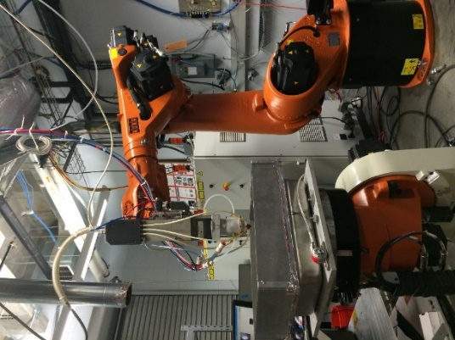

(a)

(b)

Robot arm

Laser head

Laser

Nozzle

CAD model

Printed component

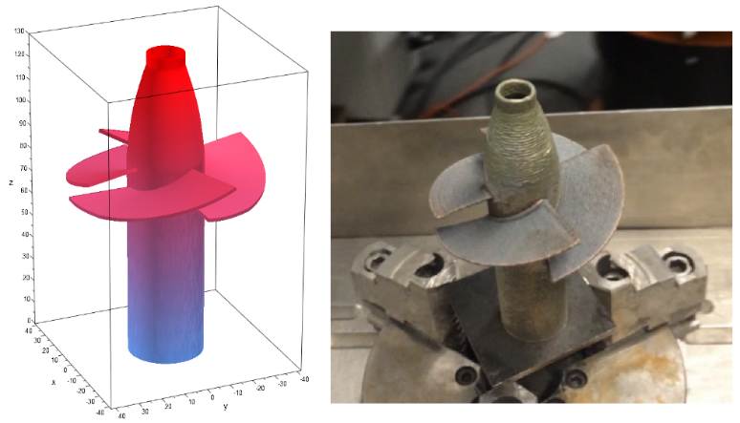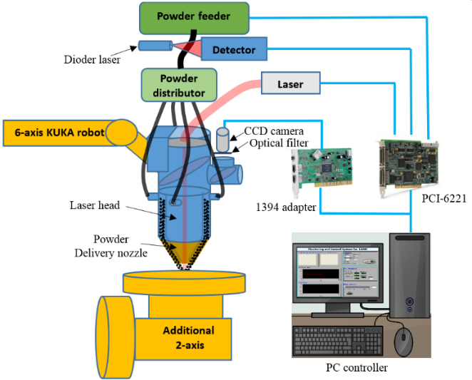

(c)

# Sensing and Control of Powder Delivery System

A controllable powder delivery system can ensure a stable and consistent deposition process. The key issue to achieve the powder delivery control is to real-time sense the powder flow rate. Powder delivery system in RCAM is equipped with a patented powder feeder [26] and an optoelectronic sensor developed for monitoring of the powder flow rate. As shown in Fig. 2, the powder feeder mainly consists of a hopper, a rotating disk, and a sucktion device. The hopper stores the powder and continuously feeds the powder to the rotating disk which has a prescribed gap $h$ with respect to the hopper. The chamber of the powder feeder is aerated with argon gas so that the powder on the disk is continuously sucked out through the sucktion device due to the pressure difference between the inside the chamber of the powder feeder and atmosphere. Given a suitable pressure difference (>10 psi), the powder flow rate is linearly related to the angular velocity of the disk which is controlled by a servo motor. By controlling the rotary speed of the servo motor, the developed powder feeder can achieve a high delivery resolution and a high scalability.

To calibrate the relationship between the powder flow rate and the motor voltage, the motor voltage was set from 0 V to 0.5 V with constant interval of 0.05 V. At each voltage, the motor was ran for about 10 seconds before any measurement was taken to ensure a stable powder flow rate. The powder flow rate at each voltage was determined by measurement of the weight of the powder delivered during a constant time period of 30 seconds. Such test was repeated three times for each voltage and the averaged weight was taken to calculate the powder flow rate at the corresponding motor voltage. As shown in Fig. 3, the maximum powder flow rate is about 1.2 g/s. The powder feeder exhibits a good linear relationship between the powder flow rate and the motor voltage when the powder flow rate is less than 1.1 g/s. In the most of the LBDMD application, the powder flow rate is less than 1.1 g/s.

An optoelectronic sensor was developed to monitor the powder flow rate under the outlet of the powder feeder. As shown in Fig. 4, the developed optoelectronic sensor consists of a diode laser, a photo diode, a small rectangular glass chamber (6.4 mm wide, 2.2 mm thick and 19.5 mm long), and a set of lenses. The laser beam emitted from the diode laser is a thin defocused light sheet with a wavelength of 658 nm and with a power less than 500 mW. The laser beam in form of line is focused by the corresponding lens before passing through the glass chamber. Due to the diffusion, absorption, and reflection of the powder stream flowing inside the glass chamber, the amount of light detected by the photo diode would change if the powder flow rate changes. The photo diode is characterized by a good linearity between the photo energy it senses and the voltage it gives out.

Fig. 2. Powder feeder

Fig. 3. Relationship between the motor voltage and the powder flow rate

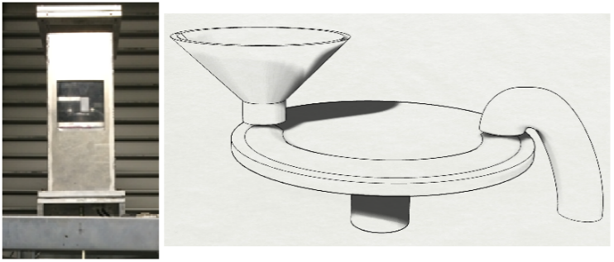

hopper

disk

sucktion

device

powder

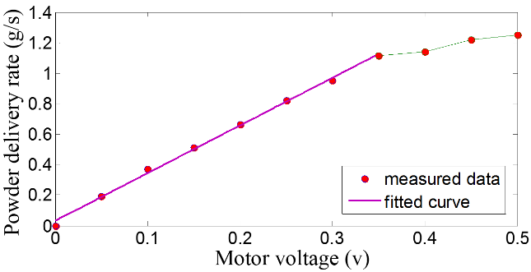

*h*

***+***

Fig. 4. The optoelectronic sensor: (a) schematic, (b) photo.

(a)

(b)

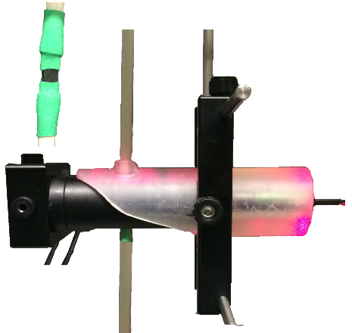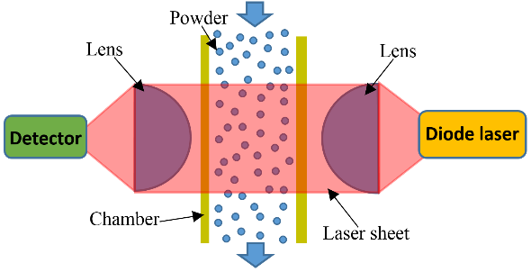

A set of experiments were conducted to test and calibrate the developed sensor. The output voltages of the sensor at different powder flow rates were acquired to build the relationship between the output voltage of the sensor and the actual powder flow rate. Here, the powder flow rates with motor voltages from 0 V to 0.5 V with a constant interval of 0.05 V were set sequentially (the powder flow rates under those motor voltages have been measured during the calibration process of the powder feeder). At each powder flow rate, the voltages of the sensor were acquired for 30 seconds with an acquisition rate of 10 kHz after the stable flow of the powder has been achieved. The averaged voltage during the 30 seconds was taken to represent the output voltages of the sensor at the corresponding powder flow rate (see Fig. 5). It can be seen that the sensor exhibits a good linear relationship between the powder flow rate and the output voltage when powder flow rate is less than 1.1 g/s (The linear delivery range of the powder feeder). In this range, the sensor can measure the powder flow rate accurately. The measured powder flow rate from the developed sensor can be used as a feedback for achieving real-time control on the powder flow rate. As shown in Fig. 6, when the measured powder flow rate deviates from the preset powder flow rate, the motor voltage would be adjusted to track the preset powder flow rate. During the deposition process, the developed sensor can also provide information on the total powder mass used for a certain deposition process, as well as to give an alarm to add powder in the hopper.

Fig. 5. Relationship between the powder flow rate and the averaged sensor voltage

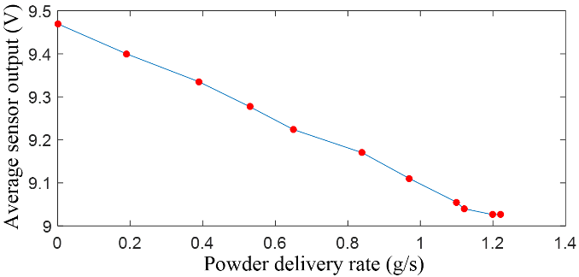

Servo Motor



Preset powder flow rate (g/s)

Voltage output (V)

Sensor

Powder delivery system

Delivery rate (g/s)

Powder flow distribution

Fig. 5

Measured flow rate (g/s)

-

Nozzle

Fig. 6. Flow chart of the sensing and control of the powder flow rate

# Sensing and Closed-loop Control of Molten Pool Size

Sensing and control of the molten pool size has a significant effect on the geometrical accuracy of the finished buildup, its microstructural properties, as well as the bonding between layers. In this study, an infrared imaging setup was coaxially installed at the laser deposition head to monitor the molten pool size. It includes a high frame rate CCD camera, an infrared filter (>695 nm), an iris, a set of optical mirrors which guided the light from the molten pool into the CCD chip of the camera, and an infrared notch-filter that blocks the laser light with a wavelength of 1070 nm. The high frame rate CCD camera was installed coaxially with respect to the laser deposition head so that the top full-field view of the molten pool can be acquired. Due to the presence of the powder flow above the molten pool, the acquisition of the video image of the molten pool was disturbed and the contour of the molten pool can not be detected accurately. An infrared filter was installed in front of the camera to eliminate the issues of the powder presence above the molten pool. Due to the existence of the infrared filter, the wavelength of the radiation received by the camera was out of the range of the visible light, so the intensity of the captured image represented the thermal distribution in the molten pool and its surrounding area based on Planck’s law [27]. In order to find the gray level on the infrared image that corresponded to the transition between the molten pool and the solid state of the material, Hu D. *et al.* [13, 28] used a black body to get the gray level of the isotherm that corresponded to the contour of the molten pool. The machine vision system consisted with a pulsed nitrogen laser was used to capture the molten pool during the deposition of the nickel powder and the obtained results were used to verify the data obtained by the infrared camera. A simpler and cheaper approach was tried in this work. The images of the referenced molten pool were coaxially acquired by both the video and the infrared camera under the same scanning conditions without powder. Then, they were overlapped to determine the isotherm on the infrared image that corresponded to the contour of the molten pool. Fig. 7-a shows the infrared image of the molten pool when scanning the substrate without powder (laser powder: 400 W, scanning speed: 20 mm/s). The resolution of the gray level image was 320x240 pixels. The video image of the molten pool under the same scanning conditions was also captured coaxially by replacing the infrared filter with a band pass optical filter (532 nm) and illuminating the molten pool by a green laser (532 nm) in power of 5 W. As shown in Fig. 7-b, the contour of the molten pool in video image is clear. By overlapping the video image over the infrared one, the contour of the molten pool on the infrared image can be determined by the isotherm with a specific value of a gray level on the real from 0 to 255. In this case, the gray level of 97 on the infrared image represented the contour of the molten pool (see Fig. 7-c).

To verify the accuracy of the gray level determined by the proposed calibration approach, a set of scanning tests with different scanning conditions (scanning speed: 0.02 mm/s, 0.03 mm/s, 0.04 mm/s; laser power: 400 W, 600 W, 800 W, 1000 W, 1200 W, 1400 W) were conducted without powder. The corresponding video images and the contours of the molten pools on the infrared images with gray level threshold of 97 are shown in Fig. 8. The shapes of the molten pools extracted from the infrared images had a high similarity with the actual shapes of the molten pools obtained from the video images. Also, as a representation of the width of the actual molten pool, the width of the heat mark on the substrate $w$ (see Fig. 7-d) after the laser scanning under different conditions was measured and are shown in Fig. 9-a for a comparison with the width of the extracted molten pool on the infrared images. They matched well with the error in $±0.1 mm$ (see Fig. 9-b), which was acceptable for the following closed-loop control. ***(Rado: you should make a comparison between the width of the heat mark by the video camera with the width of the bead of the deposited powder and see is there difference? Yaoyu: During the deposition process for calibration, powder was not used because it will block the video image. The isotherm corresponding to the contour of the molten was consistent no matter powder was used or not because they share the same melt temperature of the material. That is the base of the developed monitoring technology for molten pool size. Work done here is to verify whether gray level 97 was accurate to represent the contour. Proof was done in two ways. First, the molten pool shape from video image is the actual molten pool shape, it was proved to have a high similarity with the shape extracted from infrared with gray level set at 97. Second, as a representation of the width of the actual molten pool, the width of the heat mark were measured on substrate by ruler (not from video camera) and it was compared with the width of the molten pool from the infrared image.)***The length and area size of the extracted molten pools on the infrared images are also shown in Fig. 9. By adjusting the laser power based on the preset molten pool size, an uniform geometry of the buildup could be achieved during the deposition process.



Fig. 7. Coaxially captured images under same scanning conditions: (a) infrared image, (b) video image, (c) the contour of the molten pool on infrared image, (d) heat mark on the substrate.

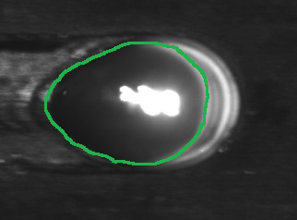

c

b

d

heat mark

*w*

a

C:\Users\Yaoyu Ding\Desktop\closed loop control paper\image\moltenpool.tif

Fig. 8. Video images and the contours of molten pool on the infrared images under different scanning conditions

Laser power (W)

Area (mm2)

Length (mm)

Width (mm)

Error (mm)



Laser power (W)

(a)

Laser power (W)

(b)

Laser power (W)

(c)

(d)

Fig. 9. Geometry of the molten pool under different scanning conditions without powder: (a) width of the molten pool extracted on the infrared images and measured from the heat marks, (b) error between the two kinds of width in (a), (c) length of the molten pool extracted on the infrared images, (d) area of the molten pool extracted on the infrared images.



To achieve an uniform molten pool size during the deposition process, the infrared image acquisition system took image of the molten pool in real time and the pixel number inside the molten pool were used as the feedback of a closed-loop control system for the molten pool size. In this study, a simple PID controller was adopted to build the closed-loop control system. ***(Rado: you need to describe the controller. Yaoyu: see the following)*** Due to the existence of time delay (less than 70 ms) in the control loop (acquire image, process image, and send analog signal to the laser control box), feed forward compensation was also introduced for the control of the molten pool size. The schematic of the control system is shown in Fig. 10. The continuous control equation can be expressed as

$u\left(t\right)=K_{p}e\left(t\right)+K_{i}\int{e\left(t\right)dt}+K_{d}\frac{de\left(t\right)}{dt}+K_{f}A_{m}(t) (1)$

$K_{p}$ is the proportional gain, $K_{i}$ is the integral gain, $K_{d}$ is the derivative gain, $e(t)$ is the error defined by $e(t)=A_{p}(t)-A_{m}(t)$, where $A_{p}(t)$ is the preset size of the molten pool (pixel number) and $A_{m}(t)$ is the measured size of the molten pool (pixel number). $A_{a}(t)$ is the actual size of the molten pool (mm2). is the feedforward gain. $u(t)$ is the analog signal (V) sent to control the laser power. The analog signal ranges from 0 V to 10 V which corresponds to laser power from 0 W to 4 kW. To implement the algorithm for the control of the molten pool size in computer, the equation is further discretized as

$u\left(k\right)=K_{p}e\left(k\right)+K_{i}T\sum_{i=0}^{k}{e\left(i\right)}+K_{d}\frac{\left(e\left(k\right)-e\left(k-1\right)\right)}{T}+K_{f}A_{m}(k) (2)$

by replacing the integral with the sum of the errors in the previous *k* steps and replacing the derivative with first order backward difference of the error between $step k$ and $step k-1$*. $step k$* is the current step. $u(k)$ is the analog signal (V) sent to control the laser power at $step k$. $e(i)$ is the error between the preset molten pool size at $step i$ and the measured molten pool size at $step i$. $T$ is the processing period. In this study, the image acquisition and its processing rate was 12 frames/s during the building process. So $T$ was determined as $\frac{1}{12}$ s.



$$e(s)$$

$$K_{p}+\frac{K_{i}}{s}+K_{d}s$$

$$u(s)$$

-

Thermal Process

Infrared image

$$K_{f}$$

$$A_{p}(s)$$

$$A_{m}(s)$$

+

thermal

field

$$A_{a}(s)$$

Fig. 10. Schematic of the closed-loop control system

To test the performance of the closed-loop control system, two “L” shape single-beam walls were built without closed-loop control and with closed-loop control, respectively. The sequence of the

deposition path is shown in Fig. 11. The “L” shape single-bead wall (two segments were both 20 mm long) was built at a corner of a square substrate (110 mm wide, 110 mm long and 3 mm thick). The laser deposition head was moved from one ending point to the other ending point to build one layer, then it was lifted up for an increment in height direction and continued to build the next layer. The solid red line indicates the path segments in which the laser power shutter was on .When the nozzle came to the path segment denoted by dashed-line, the laser power turned off. The scanning parameters are shown in Tab. 1.

Tab. 1 Deposition parameters for building “L” shape single-bead wall

|  |  |  |  |  |  |  |  |
| --- | --- | --- | --- | --- | --- | --- | --- |
| Parameter | Scanning speed (mm/s) | Laser power (W) | Molten pool size(pixel/mm2) | Powder feed rate (g/s) | Carrier gas (L/min) | Shielding gas (L/min) | Z increment (mm) |
| Without control | 5 | 400 | (Fig. 14) | 0.45 | 7.05 | 11.75 | 0.3 |
| With control | 5 | Automatically adjusted  (Fig. 17) | Preset:  12000/1.54 | 0.45 | 7.05 | 11.75 | 0.3 |

Fig. 11. Schematic of the deposition path

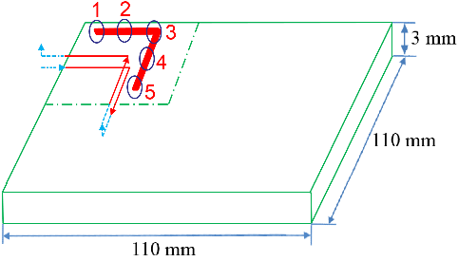

First, a 40-layer single-bead wall was built without the closed-loop control. The laser powder was set at 400 W during the whole building process. Fig. 12 shows the infrared images of the molten pools and the corresponding contours and sizes of the molten pools. It is clear that the molten pool size was varying significantly at different positions. Position 1 and position 5 were the ends of layer, where the heat conduction was limited to one side of the built wall, and there was also less time to cool down before being heated again. So the molten pool was relatively larger than in the position far from the ends. More powder was melted there, resulting in the large buildups (see Fig. 15-a) and the wider beads at two ends of the finished part were achieved (see Fig. 15-b). The molten pool at the position where the laser deposition head was changing the direction of motion (position 3) was also larger than at the other positions due to the deceleration of the robot when it changed the direction of motion. Since the nozzle stayed at the turning point relatively longer with continuous feeding of powder. The buildup was formed at this point (see Fig. 14-a). This is a common problem during building complex parts by LBDMD when changing the direction of deposition. Fig. 13 shows the variation of the molten pool size along two adjacent built layers. The segment 1-2-3 (3-2-1) located along the edge of the substrate where heat conduction was limited to one side of the substrate. So the molten pool size is relatively larger than at segment 3-4-5 (5-4-3). After the deposition of segment 3-4-5, the laser power turned off and the deposition head was lifted up. Due to the cooling during this period, the molten pool size of segment 5-4-3 was smaller than that of segment 3-4-5. ***🡨 (Rado: why there is a big difference in the two adjacent built layer, this is not clear and it is not well described. Yaoyu: see the new descriptions).***Fig. 14 displays the molten pool size during the whole deposition process. At the beginning of the building process, the substrate acted as a heat sink and only fraction of the laser energy was used to form the molten pool. Consequently, the size of the molten pool was smaller near the substrate, which leaded to a narrower bead width at the bottom of the “L” shape single-bead walls (see Fig. 15-c). As the wall grew up, the heat conduction to the substrate became less, so the bead became wider until it reached a thermal equilibrium state.

Fig. 12. Shape and size of the molten pools at different deposition positions (unit of the molten pool size: pixel number/mm2)

16023/ 2.15

14892/1.88

14294/ 1.81

15144/ 1.97

15041/1.93

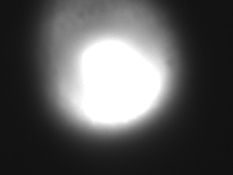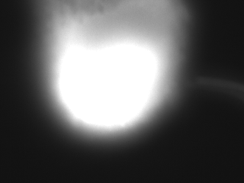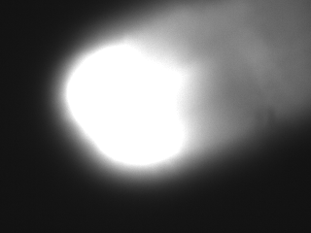

1

2

3

4

5

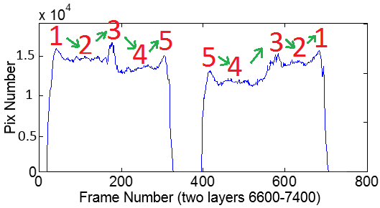

Fig. 13. Molten pool size of two adjacent built layers without control

C:\Users\Yaoyu Ding\Desktop\closed loop control paper\image\nocontro30.tif

Fig. 14. Molten pool size (pixel number) of the whole building process without control.

Frames number

C:\Users\Yaoyu Ding\Desktop\closed loop control paper\image\nocontro101.tif

Fig. 15. “L” shape single-bead wall without control of the molten pool: (a) photo, (b) horizontal cross-section of buildup, (c) vertical cross-section of buildup.

Same deposition process was conducted with the developed closed-loop control system of molten pool size. In this control system, the actual molten pool size $A_{a}(k)$ would track the preset molten pool size $A_{p}(k)$ (see Equation 2). In order to achieve an uniform molten pool size during the whole deposition process, the preset molten pool size $A_{p}(k)$ should be set at a constant value that equals to the needed molten pool size. In the test without control, the molten pool size varied from 6000 to 17000 pixels (0.77 mm2 to 2.18 mm2). To get a comparative size of molten pool in the test with control, the needed molten pool size was chosen to be 12000 pixels (1.54 mm2).***🡨 (Rado: Why 12000 pixels was chosen. Yaoyu: 12000 was chosen at will, it can be changed based on need. Here, to get a comparative geometry with the case without control, 12000 was chosen)*** Parameters of the PID controllers were tuned based on the rules in [29] and are shown at Tab. 2.

Tab. 2. Parameters of the PID controller for building “L” shape single-bead wall with control

|  |  |  |  |  |  |
| --- | --- | --- | --- | --- | --- |
| $$k$$ | $$K_{p}$$ | $$K_{i}$$ | $$K_{d}$$ | $$K_{f}$$ | $$T(s)$$ |
| 4 | $$1.3×{10}^{-4}$$ | $$0.014×{10}^{-4}$$ | $$0.04×{10}^{-4}$$ | $$0.76×{10}^{-4}$$ | 0.0833 |

Fig. 16 and Fig. 17 show the trend of the molten pool size and the laser power during the whole deposition process, respectively. To compensate for the heat sink effect by the substrate, the laser power was adjusted to about 500 W at the beginning of the deposition by the closed-loop control system. Then it was gradually decreased to 370 W until a thermal equilibrium was reached. Fig. 18 and Fig. 19 show the zoomed-in variation of the molten pool size and laser power for two adjacent built layers. Peaks of the molten pool size at ends of layers and turning position were decreased due to the action of the closed-loop control system. The built wall with closed-loop control system is shown in Fig. 20. Uniform geometry was achieved in both vertical and horizontal cross-sections. There was no buildup at the ends and turning position of the wall. The developed closed-loop control system of the molten pool size exhibited a good performance on achieving uniform buildup geometry during the LBDMD process. ***(Rado: All this description looks like a short project report. The journal paper has to have in depth procedures explain in the way that somebody else could repeat the procedure and get the same results. Yaoyu : I add why 12000 was chosen, size of the substrate and the buit wall, how to design PID controller, how to tune PID parameters )***

C:\Users\Yaoyu Ding\Desktop\closed loop control paper\image\nocontro9.tif

Fig. 16. Molten pool size (pixel number) of the whole building process with control.

C:\Users\Yaoyu Ding\Desktop\closed loop control paper\image\nocontro8.tif

Fig. 17. Laser power variation during the whole building process with control.

C:\Users\Yaoyu Ding\Desktop\closed loop control paper\image\nocontro4.tifC:\Users\Yaoyu Ding\Desktop\closed loop control paper\image\nocontro7.tif

Fig. 19. Laser power for building two adjacent layers with control.

Fig. 18. Molten pool size of two adjacent layers with control.

C:\Users\Yaoyu Ding\Desktop\closed loop control paper\image\nocontro11.tif

Fig. 20. “L” shape single-bead wall with control of the molten pool size: (a) photo, (b) horizontal cross-section of buildup, (c) vertical cross-section of buildup.

# Conclusions

A sensing and control system for a robotically controlled 8-axis LBDMD system was developed in this study. It includes the sensing and control on the powder flow rate and molten pool size. The powder flow rate under the powder feeder was sensed by a developed optoelectronic sensor, which exhibited a good linear relationship between the powder flow rate and the output voltage of the sensor. It is a main component in an on-line control system of powder flow rate in LBDMD process. An infrared imaging setup was installed coaxially with respect to the laser beam to monitor the top full-field view of the molten pool. The contour of molten pool at the infrared image was determined by overlapping it with the video image obtained without the presence of powder. It was verified that the calibrated contour of the molten pool at the infrared image can accurately represent the actual molten pool shape. A simple PID controller, combined with feed forward compensation was adopted to build a closed-loop control system for the molten pool size. Two “L” shape single-bead walls were built with and without control, respectively. The buildups at ends and the inconsistent width were eliminated by using closed-loop control.

# Acknowledgments

The authors would like to thank Mr Andrew Socha, research engineer of the Resaerch Center for Advanced Manufacturing at SMU, for his assistance in this research. The financial support of NSF under the Grand IIP-1034652 is acknowledged.

# References

[1] [Almir Heralić](http://www.sciencedirect.com/science/article/pii/S0143816609002152)[a](http://www.sciencedirect.com/science/article/pii/S0143816609002152#aff1), [Anna-Karin Christiansson](http://www.sciencedirect.com/science/article/pii/S0143816609002152)[a](http://www.sciencedirect.com/science/article/pii/S0143816609002152#aff1), [Mattias Ottosson](http://www.sciencedirect.com/science/article/pii/S0143816609002152)[a](http://www.sciencedirect.com/science/article/pii/S0143816609002152#aff1), [Bengt Lennartson](http://www.sciencedirect.com/science/article/pii/S0143816609002152)[b](http://www.sciencedirect.com/science/article/pii/S0143816609002152#aff2). Increased stability in laser metal wire deposition through feedback from optical measurements. [Optics and Lasers in Engineering](http://www.sciencedirect.com/science/journal/01438166) 2010; [Volume 48, Issue 4](http://www.sciencedirect.com/science/journal/01438166/48/4), Pages 478–485.

[2] [Almir Heralić](http://www.sciencedirect.com/science/article/pii/S0143816612001017)[a](http://www.sciencedirect.com/science/article/pii/S0143816612001017#aff1), [Anna-Karin Christiansson](http://www.sciencedirect.com/science/article/pii/S0143816612001017)[a](http://www.sciencedirect.com/science/article/pii/S0143816612001017#aff1), [Bengt Lennartson](http://www.sciencedirect.com/science/article/pii/S0143816612001017). Height control of laser metal-wire deposition based on iterative learning control and 3D scanning. [Optics and Lasers in Engineering](http://www.sciencedirect.com/science/journal/01438166) 2012; [Volume 50, Issue 9](http://www.sciencedirect.com/science/journal/01438166/50/9), Pages 1230–1241.

[3] [http://www.industrial-lasers.com/articles/print/volume-29/issue-5/features/process-monitoring-in laser-additive-manufacturing.html](http://www.industrial-lasers.com/articles/print/volume-29/issue-5/features/process-monitoring-in-laser-additive-manufacturing.html).

[4] [J. Gockel](http://www.maneyonline.com/action/doSearch?ContribStored=Gockel%2C+J)[1](http://www.maneyonline.com/doi/full/10.1179/1743284714Y.0000000704?utm_campaign=MST+special+issue+Additive+Manufacturing&utm_source=emailCampaign&utm_medium=email&utm_content=#aff1), [J. Fox](http://www.maneyonline.com/action/doSearch?ContribStored=Fox%2C+J), [J. Beuth](http://www.maneyonline.com/action/doSearch?ContribStored=Beuth%2C+J), [R. Hafley](http://www.maneyonline.com/action/doSearch?ContribStored=Hafley%2C+R). Integrated melt pool and microstructure control for Ti–6Al–4V thin wall additive manufacturing. [Materials Science and Technology](http://www.maneyonline.com/loi/mst). Volume 31, Issue 8 (June 2015), pp. 912-916.

[5] [Gustavo Tapia](https://manufacturingscience.asmedigitalcollection.asme.org/solr/searchresults.aspx?author=Gustavo+Tapia&q=Gustavo+Tapia), [Alaa Elwany](https://manufacturingscience.asmedigitalcollection.asme.org/solr/searchresults.aspx?author=Alaa+Elwany&q=Alaa+Elwany). A review on process monitoring and control in metal-Based additive Manufacturing. [Journal of Manufacturing Science and Engineering.](https://manufacturingscience.asmedigitalcollection.asme.org/issue.aspx?journalid=125&issueid=931017) J. Manuf. Sci. Eng 136(6), 060801 (Oct 24, 2014).

[6] [Lie Tang](http://manufacturingscience.asmedigitalcollection.asme.org/solr/searchresults.aspx?author=Lie+Tang&q=Lie+Tang), [Jianzhong Ruan](http://manufacturingscience.asmedigitalcollection.asme.org/solr/searchresults.aspx?author=Jianzhong+Ruan&q=Jianzhong+Ruan), [Robert G. Landers](http://manufacturingscience.asmedigitalcollection.asme.org/solr/searchresults.aspx?author=Robert+G.+Landers&q=Robert+G.+Landers) and [Frank Liou](http://manufacturingscience.asmedigitalcollection.asme.org/solr/searchresults.aspx?author=Frank+Liou&q=Frank+Liou). Variable Powder flow rate Control in Laser Metal Deposition Processes. J. Manuf. Sci. Eng 130(4), 041016 (Jul 22, 2008).

[7] Theore J. Zhang, J. Coulthard. Theoretical and experimental studies of the spatial sensitivity of an electrostatic pulverised fuel meter, Journal of Electrostatics 2005 63 (12) 1133–1149.

[8] J. Krabicka, Y. Yan. Finite-element modeling of electrostatic sensors for the ﬂow measurement of particles in pneumatic pipelines, IEEE Transactions on Instrumentation and Measurement 58 (8) (2009) 2730–2736.

[9] L. Peng, Y. Zhang, Y. Yan. Characterization of electrostatic sensors for ﬂow measurement of particulate solids in square-shaped pneumatic conveying pipelines, Sensors and Actuators A 141 (2008) 59–67.

[10] [Yingna Zheng](http://www.sciencedirect.com/science/article/pii/S0263224111000297), [Qiang Liu](http://www.sciencedirect.com/science/article/pii/S0263224111000297). Review of techniques for the mass ﬂow rate measurement of pneumatically conveyed solids. Measurement 2011; [Volume 44, Issue 4](http://www.sciencedirect.com/science/journal/02632241/44/4), Pages 589–604.

[11] D. Song, L. Peng, G. Lu, S. Yang, Y. Yan, Digital image processing based mass ﬂow rate measurement of gas/solid two-phase ﬂow, in: The 6th International Symposium on Measurement Techniques for Multiphase Flows, Journal of Physics: Conference Series 147 (1) (2009) 1–8.

[12] J.J. Nieuwland, R. Meijer, J.A.M. Kuipers, W.P.M. Swaaij, Measurements of solids concentration and axial solids velocity ingas–solid two-phase ﬂows, Powder Technology 87 (2) (1996) l 27–139.

[13] [Dongming Hu](http://www.sciencedirect.com/science/article/pii/S0890695502001633), [Radovan Kovacevic](http://www.sciencedirect.com/science/article/pii/S0890695502001633). Sensing, modeling and control for laser-based additive manufacturing. [International Journal of Machine Tools and Manufacture](http://www.sciencedirect.com/science/journal/08906955). 2003; [Volume 43, Issue 1](http://www.sciencedirect.com/science/journal/08906955/43/1), Pages 51–60

[14] [Gustavo Tapia](https://manufacturingscience.asmedigitalcollection.asme.org/solr/searchresults.aspx?author=Gustavo+Tapia&q=Gustavo+Tapia), [Alaa Elwany](https://manufacturingscience.asmedigitalcollection.asme.org/solr/searchresults.aspx?author=Alaa+Elwany&q=Alaa+Elwany). A Review on Process Monitoring and Control in Metal-Based Additive Manufacturing. J. Manuf. Sci. Eng 136(6), 060801 (Oct 24, 2014) .

[15] [Jun Xiong](http://www.sciencedirect.com/science/article/pii/S0959652612005410), [Guangjun Zhang](http://www.sciencedirect.com/science/article/pii/S0959652612005410), [Zhilong Qiu](http://www.sciencedirect.com/science/article/pii/S0959652612005410), [Yongzhe Li](http://www.sciencedirect.com/science/article/pii/S0959652612005410). Vision-sensing and bead width control of a single-bead multi-layer part: material and energy savings in GMAW-based rapid manufacturing. [Journal of Cleaner Production](http://www.sciencedirect.com/science/journal/09596526) [Volume 41](http://www.sciencedirect.com/science/journal/09596526/41/supp/C), February 2013, Pages 82–88.

[16] [J. Gockel](http://www.maneyonline.com/action/doSearch?ContribStored=Gockel%2C+J)[1](http://www.maneyonline.com/doi/full/10.1179/1743284714Y.0000000704?utm_campaign=MST+special+issue+Additive+Manufacturing&utm_source=emailCampaign&utm_medium=email&utm_content=#aff1), [J. Fox](http://www.maneyonline.com/action/doSearch?ContribStored=Fox%2C+J), [J. Beuth](http://www.maneyonline.com/action/doSearch?ContribStored=Beuth%2C+J), [R. Hafley](http://www.maneyonline.com/action/doSearch?ContribStored=Hafley%2C+R). Integrated melt pool and microstructure control for Ti–6Al–4V thin wall additive manufacturing. [Materials Science and Technology](http://www.maneyonline.com/loi/mst). Volume 31, Issue 8 (June 2015), pp. 912-916.

[17] Held, G., 2008, Introduction to Light Emitting Diode Technology and Applications, CRC Press, Boca Raton, FL.

[18] Bi, G., Gasser, A., Wissenbach, K., Drenker, A., and Poprawe, R., 2006, Identification and Qualification of Temperature Signal for Monitoring and Control in Laser Cladding. Opt. Lasers Eng., 44(12), pp. 1348–1359.

[19] Bi, G., Schurmann, B., Gasser, A., Wissenbach, K., and Poprawe, R., 2007, “Development and Qualification of a Novel Laser-Cladding Head With Integrated Sensors,” Int. J. Mach. Tools Manuf., 47(3), pp. 555–561.

[20] Teledyne DALSA Inc., 2013, “CCD vs. CMOS: Which Is better? It’s Complicated,” http://www.teledynedalsa.com/imaging/knowledge-center/appnotes/ccd-vs-cmos/.

[21] Shishkovsky, I., Scherbakov, V., Morozov, Y., Kuznetsov, M., and Parkin, I. Surface Laser Sintering of Exothermic Powder Compositions. J. Therm. Anal. Calorim., 91(2), pp. 427–436.

[22] T. Hua, C. Jing, L. Xin, Z. Fengying, H. Weidong. Research on molten pool temperature in the process of laser rapid forming. J Mater Process Technol, 198 (2008), pp. 454–462.

[23] [G. Bi](http://www.sciencedirect.com/science/article/pii/S0924013612003020), [C.N. Sun](http://www.sciencedirect.com/science/article/pii/S0924013612003020), [A. Gasser](http://www.sciencedirect.com/science/article/pii/S0924013612003020). Study on influential factors for process monitoring and control in laser aided additive manufacturing. [Journal of Materials Processing Technology](http://www.sciencedirect.com/science/journal/09240136). [Volume 213, Issue 3](http://www.sciencedirect.com/science/journal/09240136/213/3), March 2013, Pages 463–468.

[24] [Lijun Song](http://link.springer.com/search?facet-creator=%22Lijun+Song%22), [Vijayavel Bagavath-Singh](http://link.springer.com/search?facet-creator=%22Vijayavel+Bagavath-Singh%22), [Bhaskar Dutta](http://link.springer.com/search?facet-creator=%22Bhaskar+Dutta%22), [Jyoti Mazumder](http://link.springer.com/search?facet-creator=%22Jyoti+Mazumder%22). Control of melt pool temperature and deposition height during direct metal deposition process. [The International Journal of Advanced Manufacturing Technology](http://link.springer.com/journal/170). January 2012, Volume 58, [Issue 1-4](http://link.springer.com/journal/170/58/1/page/1), pp 247-256.

[25] [Lie Tang](https://manufacturingscience.asmedigitalcollection.asme.org/solr/searchresults.aspx?author=Lie+Tang&q=Lie+Tang) and [Robert G. Landers](https://manufacturingscience.asmedigitalcollection.asme.org/solr/searchresults.aspx?author=Robert+G.+Landers&q=Robert+G.+Landers). Melt pool temperature control for laser metal deposition processes -part I: online temperature control. J. Manuf. Sci. Eng. 132(1), 011010 (Jan 21, 2010).

[26] Valant, M. and Kovacevic, R., “Powder Delivery System and Method”, US Patent No. [7045738,](http://www.google.com/patents?id=D8B3AAAAEBAJ&printsec=abstract&zoom=4&source=gbs_overview_r&cad=0#v=onepage&q&f=false) issued on May 16, 2006.

[27] Michalski, L., Eckersdorf, K., and McGhee, J., 1991. Temperature Measurement, Wiley, West Sussex, UK.

[28] Kovacevic, R., Hu, D., and Valant, M., “System and Method for Controlling the Size of the Molten Pool in Laser-based Additive Manufacturing”, US Patent No. [6995334,](http://www.google.com/patents?id=OqN3AAAAEBAJ&printsec=abstract&zoom=4&source=gbs_overview_r&cad=0#v=onepage&q&f=false) issued on February 7, 2006.

[29] S. Skogestad. Probably the best simple PID tuning rules in the world, in: AIChE Annual Meeting, Reno, NV, USA, November 2001.